Marks-50 FINAL EXAM PAPER OF HTML Timing-1.5hrs.

- Perform given Programs.
- Write the code of an application which describes the header code in html.

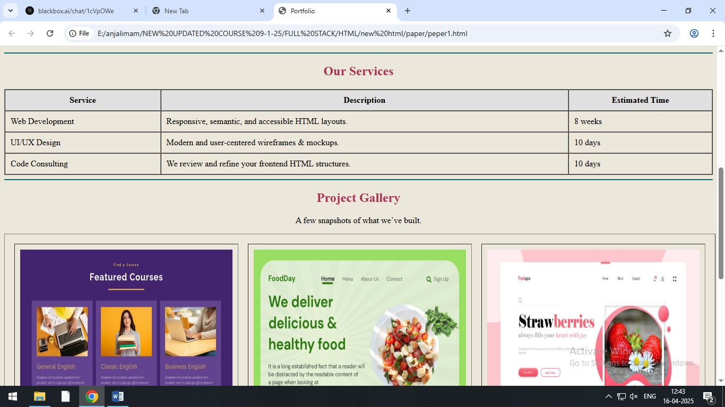
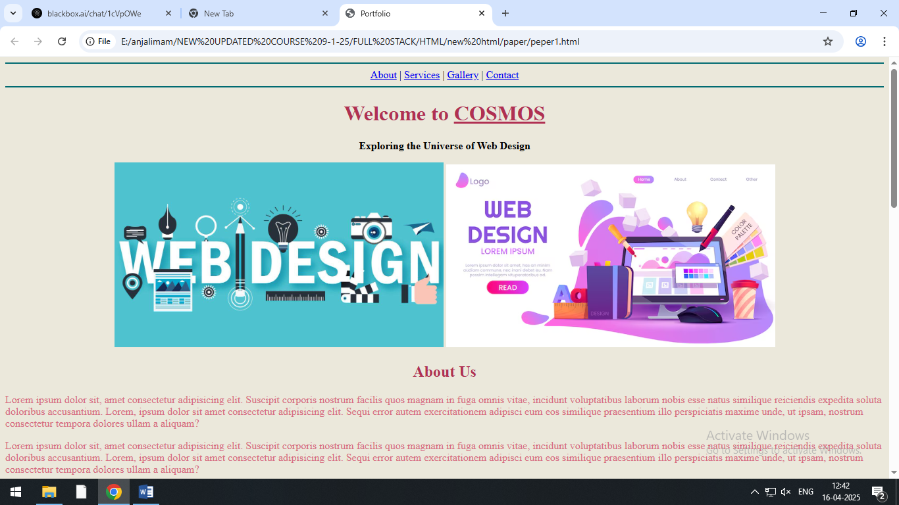

Marks-50 FINAL EXAM PAPER OF HTML Timing-1.5hrs.

- Perform given Programs.
- Write the code of an application which describes the header code in html.

